*Michigan Department of Natural Resources Status of the Fishery Resource Report 91-1, 1991*

*Renumbered in 2024, Status of the Fishery Resource Report 0001*

DEEP LAKE

*Barry County (T3N, R10W, Section 26) Surveyed September and October 1988*

# James L. Dexter Environment

Deep Lake is a kettle lake of glacial origin located in west-central Barry County within the Yankee Springs Recreation Area (see [map of Deep Lake](http://www.michigandnr.com/PUBLICATIONS/PDFS/ifr/ifrlibra/status/images/91-1.gif)). It lies about 10 miles west of Hastings, Michigan.

Rolling hills and sandy soils characterize the geography of the area. The watershed is predominantly a mixture of mature oak and red pine forest, with a large amount of old fallow farmland returning to forest. The immediate area surrounding the lake is primarily scrub-shrub and wetland underlaid with well-drained loamy sand soils. One small unnamed inlet (top quality coldwater) is at the southern end of the lake and drains through Houghton muck soils. A small outlet, Turner Creek (top quality warmwater), is on the north end; its water flows to the Thornapple River in the Grand River watershed of Lake Michigan.

Deep Lake is 32.4 acres in size and up to 35 feet deep. Shoals, comprised primarily of sand and marl, cover 30-40% of the area. Vegetation is sparse except for cattails and rushes.

Water quality conditions were last surveyed on August 18, 1986. The water was colorless, and quite clear with a Secchi disk reading of 13 feet. Within the water column, alkalinity ranged from 134 ppm to 145 ppm and pH ranged from 7.4 to 8.4. These indicate the water is hard and well- buffered. Temperature varied from 77ÝF at the surface to 48ÝF at the bottom, with the thermocline occurring between 10 and 20 feet.

Typically, summer oxygen levels are sufficient for fish down to a depth of 25 feet. Dissolved oxygen in the thermocline ranged from 5-10 ppm. Overall water quality is excellent and presents a very good environment for a two-story fishery, with a combination of warmwater fish in the upper layer and trout in mid-water.

Development around Deep Lake is very limited. The Yankee Springs Recreation Area maintains a campground (120 sites) and a public launch site on the northeast shore. There are a total of five buildings on the lake, but three of these are scheduled to be demolished in 1990, as the state has purchased this land recently.

# Fishery Resource

According to historical records, Deep Lake has been actively managed by the state since 1934, when largemouth bass were stocked. Bluegills, yellow perch, and more largemouth bass were stocked in varying numbers over the next 7 years. Rainbow trout fingerlings were stocked for the first time in 1942 and 1943 to try to create a two-story fishery.

In 1944, gill nets were used to evaluate the rainbow trout plants. No rainbows were found, but four large brown trout were captured. Hazzard (1944) suggested that brown trout had not been stocked for at least 10 years, and that these fish were presumably the result of natural reproduction (from the inlet). We have no records, however, of stocking prior to 1934.

The fish community in the 1930s and 1940s consisted mainly of bluegills, largemouth bass, and yellow perch. Ciscoes were reported by fishermen, but their presence has never been verified. Rock bass, black crappie, and pumpkinseeds were also available to the angler.

The fish community was most recently surveyed on September 29-30 and October 20- 21, 1988. The netting effort entailed an overnight set of two trap nets and six gill nets and a second overnight set of the gill nets.

Today's fish community is similar to that of 50 years ago (Table 1). Large bluegills and perch remain the mainstay of the fishery. Other warmwater species are limited by the small amount of shoal habitat. Largemouth bass are not very abundant.

Northern pike are new to the lake. We netted a 40-inch pike in 1988, and in May 1989, a 43-inch pike weighing 20 pounds was caught by an angler and entered in the Master Angler Award program. Pike may have entered Deep Lake either through Turner Creek (which drains into the Thornapple River) or by an unapproved private introduction.

It is interesting to note that rainbow trout yearlings, stocked in the spring since 1966 at 43 per acre, formerly provided a very good fishery. In the mid-1980s, however, survival of stocked rainbows may have declined: catches dwindled, and fishing pressure dropped off. The 1988 survey revealed practically the same results as the 1944 survey- no rainbows but five wild brown trout. The decline in the rainbow fishery could be linked to the presence of northern pike. Just a few large pike could decimate the rainbow stockings. Beginning in 1989, management direction changed to stocking brown trout to supplement their low level of natural reproduction.

Growth rates of important game fish species are good (Table 2). Yellow perch are growing above state average, and bluegill are growing at state average. Wild brown trout are growing very rapidly.

Age composition and survival characteristics of sport fish appear to be normal, considering that relatively few fish were sampled and that the survey nets were not effective for small fish (Table 3). For perch and bluegill, young fish have been regularly recruited to the populations and the longevity of adults is satisfactory. Presence of age- II and age-III brown trout indicates that environmental conditions will be good for the carry-over of stocked trout from year to year.

Deep Lake produces larger bluegill and perch than many southern Michigan lakes due to a favorable combination of growth and survival. On a scale of 1 to 7 (Schneider 1990), the quality of the bluegill population ranked 4.8, "good". Bluegills as large as 8.4 inches, perch up to 11.1 inches, and brown trout up to 19.9 inches were taken during the 1988 survey.

Fishing on Deep Lake is a very pleasurable experience. It does not receive intense fishing pressure, and the water is clear and inviting. Water quality will be preserved because the state owns almost all the land surrounding the lake. Access is assured through the camp-ground. Bluegills and yellow perch should continue to provide good fishing. Hopefully fishermen will key in on the brown trout now stocked. With only a few buildings visible from any point on the lake, and the good fishing available, the lake provides a high quality experience.

# Management Direction

This lake will continue to be managed as a two-story fishery. Currently the only special management practiced on Deep Lake is the annual stocking of 1,300 yearling brown trout. As very few lakes in southern Michigan are stocked with browns, we are not sure how good a fishery they will provide at Deep Lake. The possibility exists that a very high quality fishery will develop, as evidenced by the lake's history of large brown trout.

Our goals for the next 6 years will be to (1) maintain the bluegill and yellow perch fishery, and (2) develop the brown trout fishery.

No problems are expected to develop with goal Number 1; however, goal Number 2 may be difficult to reach. Brown trout are notoriously more difficult to catch than rainbows. We will rely heavily on reports from park personnel to determine if anglers are fishing for browns and their success rate. In addition, we may evaluate the brown trout fishery by tagging fish and soliciting tag returns from anglers.

Report completed: February 6, 1990.

# References

Hazzard, A. S. 1944. Management check on Deep Lake, Barry County. Michigan Department of Conservation, Fisheries Research Report 970, Ann Arbor.

Schneider, J. C. 1990. Classifying bluegill populations from lake survey data. Michigan Department of Natural Resources, Fisheries Technical Report 90-10, Ann Arbor.

**Table 1.** Number, weight, and length indices of fish collected from Deep Lake with gill and trap nets, September 29-30 and October 20-21, 1988.

|  |  |  |  |  |  |  |  |
| --- | --- | --- | --- | --- | --- | --- | --- |
| **Species** | **Number** | **Percent by number** | **Weight (pounds)** | **Percent by weight** | **Length range (inches)1** | **Average length** | **Percent legal size2** |
| Bullhead spp. | 84 | 38.9 | 34.8 | 36.4 | 5-12 | 8.9 | 92 |
| Bluegill | 53 | 24.5 | 8.9 | 9.3 | 5.2-8.4 | 6.4 | 55 |
| Yellow perch | 30 | 13.9 | 9.0 | 9.4 | 6.6-11.1 | 9.1 | 97 |
| Lake chubsucker | 15 | 6.9 | 3.5 | 3.7 | 6-8 | 7.5 | - |
| Pumpkinseed | 6 | 2.8 | 1.6 | 1.7 | 9-11 | 5.5 | 17 |
| Grass pickerel | 6 | 2.8 | 1.6 | 1.7 | 9-11 | 10.5 | - |
| Brown trout | 5 | 2.3 | 7.7 | 8.1 | 12.8-19.9 | 15.9 | 100 |
| Largemouth bass | 5 | 2.3 | 0.7 | 0.7 | 6.3-9.3 | 8.1 | 0 |
| Rock bass | 3 | 1.4 | 0.7 | 0.7 | 5-6 | 5.8 | 33 |
| Warmouth | 3 | 1.4 | 0.1 | 0.1 | 4 | 4.5 | 0 |
| Bowfin | 2 | 0.9 | 8.9 | 9.3 | 11-29 | 20.5 | - |
| Golden shiner | 2 | 0.9 | 0.3 | 0.3 | 7-8 | 8.0 | - |
| Northern pike | 1 | 0.5 | 16.2 | 17.0 | - | 40.2 | 100 |
| White sucker | 1 | 0.5 | 1.5 | 1.6 | - | 14.5 | - |
| Total | 216 | 100.0 | 95.5 | 100.0 |  |  |  |

1Note some fish were measured to 0.1 inch, others to inch group: e.g., "5" = 5.0 to 5.9 inches; "12" = 12.0 to 12.9 inches; etc.

2Percent legal size or acceptable size for angling.

**Table 2.** Average total length (inches) at age, and growth relative to the state average, for five species of fish sampled from Deep Lake with gill and trap nets, September 29- 30 and October 20-21, 1988. Number of fish aged is given in parentheses.

|  |  |  |  |  |  |  |  |  |  |
| --- | --- | --- | --- | --- | --- | --- | --- | --- | --- |
|  |  |  |  |  |  |  |  |  | **Mean** |
|  |  |  |  | **Age** |  |  |  |  | **growth** |
| **Species** | **I** | **II** | **III** | **IV** | **V** | **VI** | **VII** | **VIII** | **index1** |
| Brown trout | - | 15.2 | 19.9 | - | - | - | - | - | - |
|  | - | (4) | (1) | - | - | - | - | - |  |
| Bluegill | - | 5.4 | 5.9 | 7.0 | 7.8 | 8.3 | - | - | +0.3 |
|  | - | (3) | (9) | (13) | (3) | (3) | - | - |  |
| Yellow perch | 6.6 | 8.0 | 8.7 | 9.7 | 11.1 | - | - | - | +1.2 |
|  | (1) | (3) | (15) | (7) | (1) | - | - | - |  |
| Largemouth bass | - | 7.4 | 9.3 | - | - | - | - | - | - |
|  | - | (4) | (1) | - | - | - | - | - |  |
| Northern pike | - | - | - | - | - | - | - | 40.2 | - |
|  | - | - | - | - | - | - | - | (1) |  |

1Mean growth index is the average deviation from the state average length at age.

**Table 3.** Estimated age frequency (percent) of five species of fish caught from Deep Lake with gill and trap nets, September 29-30 and October 20-21, 1988.

|  |  |  |  |  |  |  |  |  |  |
| --- | --- | --- | --- | --- | --- | --- | --- | --- | --- |
|  |  |  |  | **Age** |  |  |  |  | **Number** |
| **Species** | **I** | **II** | **III** | **IV** | **V** | **VI** | **VII** | **VIII** | **caught** |
| Brown trout | - | 80 | 20 | - | - | - | - | - | 5 |
| Bluegill | - | 15 | 40 | 32 | 8 | 5 | - | - | 53 |
| Yellow perch | 4 | 11 | 56 | 26 | 3 | - | - | - | 30 |
| Largemouth bass | - | 80 | 20 | - | - | - | - | - | 5 |
| Northern pike | - | - | - | - | - | - | - | 100 | 1 |

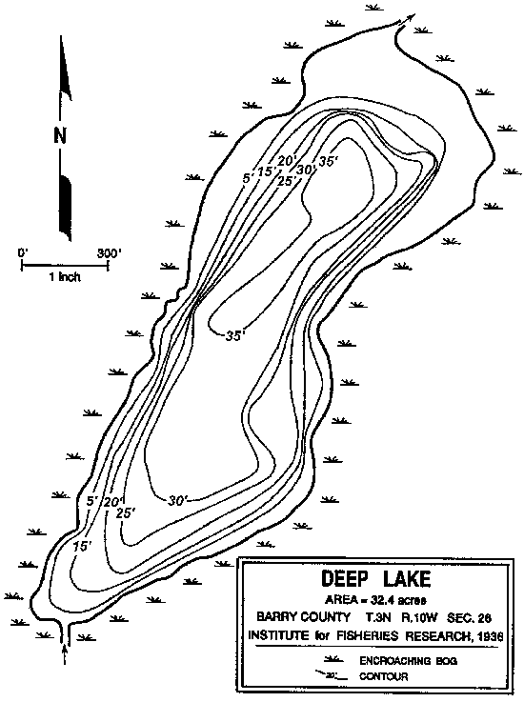

**Last Update:** 08/06/02

**Web Author:** [*Tina M. Tincher, Librarian*](mailto:tinchert@michigan.gov)

**Questions, comments and suggestions are always welcome! Send them to** [**tinchert@michigan.gov**](mailto:tinchert@michigan.gov)