*Michigan Department of Natural Resources*

*Status of the Fishery Resource Report 91-9, 1991*

*Renumbered in 2024, Status of the Fishery Resource Report 0009*

TRAVIS CREEK

*Kalamazoo County (T1S, R11W, Sections 5, 8, and 9)*

# Surveyed October 9, 1989 J

# James L. Dexter, Jr.

**Environment**

Travis Creek is a small first order stream of top quality coldwater. It is located in Cooper Township in the northeastern corner of Kalamazoo County. The city of Plainwell is located about 2 miles to the north. The stream originates in springs in a marshy woodland and flows north and east to the Kalamazoo River. It appears only on United States Geological Survey topographical maps.

The watershed of Travis Creek is very small. This is evident by the creek's small size and short length. The surrounding area is composed mainly of fallow farmland, marshy lowland, and wetland forest. The bottom soils are poorly drained, consisting of Houghton muck in the upper half and Glendora sandy loams in the lower half.

The creek is about 3.1 miles long and falls about 70 feet between the headwaters and its mouth. The average width is 4 feet. Depths average 6 inches, with most deep water occurring in the lower end. Rock, gravel, and cobble make up 40-60% of the stream bottom substrate, while sand, silt, and clay compose the remainder. Water velocities are moderate to slow. Overall habitat is excellent, consisting of a mosaic of logs, rocks, undercut banks, overhanging brush, pools, riffles, and watercress.

Water quality appears to be excellent, based on the presence of brook trout and mottled sculpin. Development on the creek is sparse, with only a few homes and a few cow pastures bordering the banks. Most of the channel corridor is too wet for development. There is no public access except at three road crossings. We do not know if access is a problem.

# Fishery Resource

This survey represents the first documented work conducted by any state agency on the creek. Backpack electroshocking (240-V pulse DC) was conducted at three stations on October 9, 1989. Currently, it supports a very good wild brook trout population. According to records, brook trout were stocked in 1937, 1938, 1941, 1942, 1943, 1949, and 1951. Stocked trout varied from month old fingerlings to yearlings.

Travis Creek supports a diverse group of fish species (Table 1). The lower end is dominated by minnows. No trout were found there, although water quality is suitable for them. The middle reaches have some brook trout and support fewer species than the lower end. The upper reaches have many brook trout and only four other species.

Length-frequency analysis (Figure 1) indicates that our sampling did not effectively cover nursery areas. Only a few young-of-the-year trout were captured. Many adult trout in spawning colors were handled, though. I do not believe this lack of young trout represents some degree of year-class failure, but rather our inefficiency at sampling the proper reaches of the creek. Catch per unit effort for brook trout was 39/hour. Legal-sized trout accounted for 12.8% of the sample. Based on length frequencies, most brook trout appeared to be age I or II.

# Management Direction

An obstacle to keeping the stream in its present state or improving the resource are the numerous ponds connected to the creek. Air photos from 1988 show nine separate ponds along the watercourse. There is no way to know what species exist in these ponds. These unknown species may eventually end up in the creek.

During our survey, it appeared that there was no fishing pressure on the creek. No trails were evident, and the brush was very thick. One riparian that we talked to was very surprised to learn that trout were present in the creek. He indicated that he had never seen anyone fishing it.

One management option in a stream like this is chemical treatment and trout restocking. Because of the short nature of the stream, the ease of rough fish infiltration from the Kalamazoo River, possible pond fish species contamination, and low-to nonexistent exploitation, no management is necessary at this time. However, the addition of Travis Creek to the Designated Trout Streams list (DFI 101.87) for protection should be completed as soon as possible. This stream should be resurveyed in 10 years.

Report completed: February 23, 1990.

**Table 1**.-Species, relative abundance, and length range of fish sampled by backpack electroshocking in Travis Creek, October 9, 1980.

|  |  |  |  |
| --- | --- | --- | --- |
| Species | Number | Percent | Length range (inches)1 |
| Creek chub | 125 | 39.8 | 2-7 |
| Spotfin shiner | 69 | 21.9 | 2-4 |
| Mottled sculpin | 41 | 13.0 | 2-3 |
| Brook trout | 39 | 12.4 | 2-8 |
| Common shiner | 9 | 2.9 | 3-4 |
| Bluegill | 7 | 2.2 | 2-5 |
| Green sunfish | 7 | 2.2 | 2-4 |
| White sucker | 7 | 2.2 | 2-4 |
| Yellow bullhead | 6 | 1.9 | 2-5 |
| Johnny darter | 2 | 0.6 | 2-3 |
| Central mudminnow | 1 | 0.3 | 6 |
| Bowfin | 1 | 0.3 | 2 |
| Grass pickerel | 1 | 0.3 | 5 |
| Total | 315 | 100.0 |  |

1Fish were measured to inch group: e.g., "1" = 1.0 to 1.9 inches; "2" = 2.0 to 2.9 inches; etc.

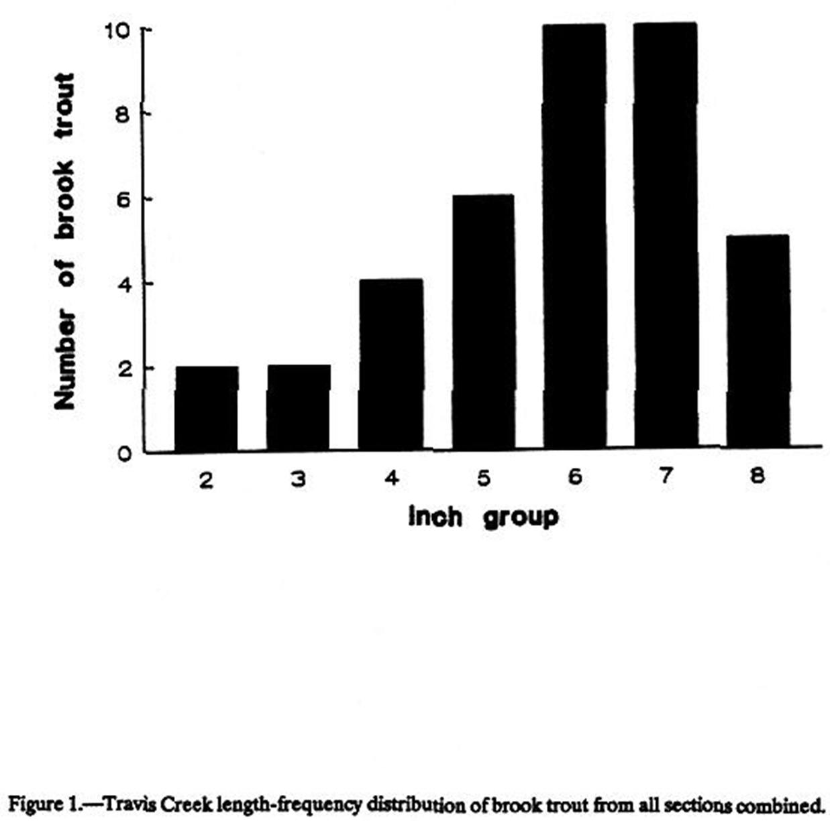

**Last Update:** 08/06/02

**Web Author:** [*Tina M. Tincher, Librarian*](mailto:tinchert@michigan.gov)

**Questions, comments and suggestions are always welcome! Send them to** [**tinchert@michigan.gov**](mailto:tinchert@michigan.gov)